**Session 5 (unit-3): Classes and Object and concept of Encapsulation**

|  |  |
| --- | --- |
| Roll No. A016 | Name: Varun Khadayate |
| Program: B-Tech (CSBS) | Division: SY |
| Batch: 1 | Date of Submission: 20-09-2020 |

1. **Create a class Student having fields name, rollno, division, id and marks in 3 subjects. The class also has three methods accept_details(),  average_marks() and display_details() as member procedures. Accept the details of two students as command line arguments and Display their information.**

**ANS:**

**CODE:** #include<iostream>

#include<conio.h>

using namespace std;

class student

{

char name[20],divs[3];

int rno,mk1,mk2,mk3;

public:

void accept_details()

{

cout<<"\n Enter your name::";

cin>>name;

cout<<"\n Enter the roll number::";

cin>>rno;

cout<<"\n Enter the marks in the 3 subjects::";

cin>>mk1>>mk2>>mk3;

cout<<"\n Enter the division::";

cin>>divs;

}

double average_marks()

{

return (mk1+mk2+mk3)/3;

}

void display_details()

{

cout<<"\t The result";

cout<<"\n\n Name::"<<name;

cout<<"\n\n Roll No.::"<<rno;

cout<<"\n\n Division::"<<divs;

cout<<"\n\n Average marks::"<<average_marks();

}

};

int main()

{

student s1,s2;

cout<<"\tFor student 1";

s1.accept_details();

s1.average_marks();

s1.display_details();

cout<<"\n\n\tFor student 2";

s2.accept_details();

s2.average_marks();

s2.display_details();

return 0;

getch();

}

**OUTPUT:**

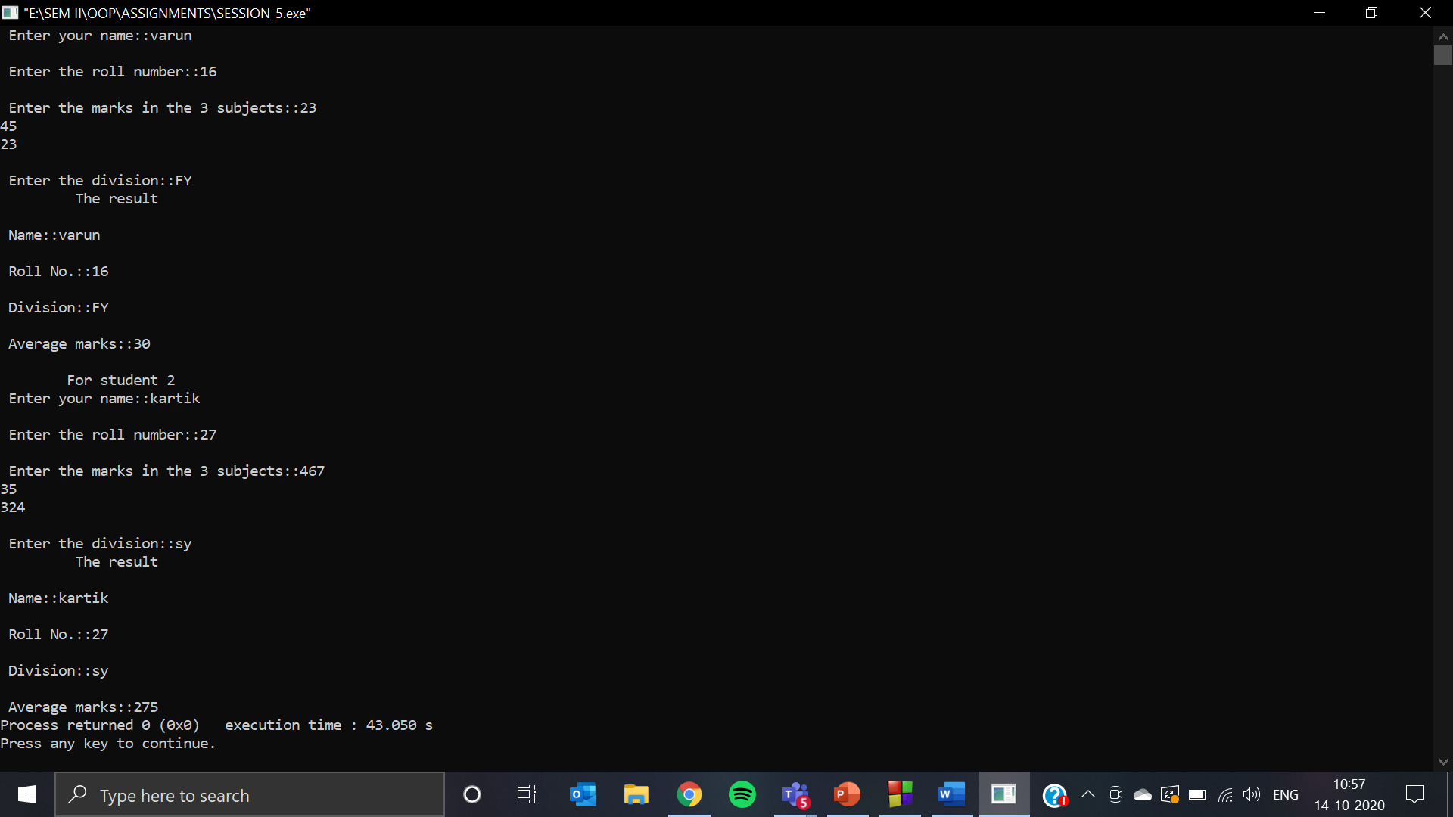

1. **Write a program by creating an 'Employee' class having the following methods and print the final salary.**
   1. **'getInfo()' which takes the employee Id, his salary and number of hours of work per day of employee as parameter**
   2. **'AddSal()' which adds $10 to salary of the employee if it is less than $500.**
   3. **'AddWork()' which adds $5 to salary of employee if the number of hours of work per day is more than 6 hours.**

**ANS:**

**CODE:** #include<iostream>

#include<conio.h>

using namespace std;

class employee

{

char emp_id[23];

int salary,hrs;

public:

void getInfo()

{

cout<<"\t EMPLOYEE DETAILS INPUT";

cout<<"\n Employee id::";

cin>>emp_id;

cout<<"\n Salary in dollars::";

cin>>salary;

cout<<"\n Enter the number of working hours per day::";

cin>>hrs;

}

double Addsal()

{

if(salary<500)

salary = salary + 10;

return salary;

}

double Addwork()

{

if(hrs>6)

salary = salary + 5;

return salary;

}

void DispInfo()

{

cout<<"\t EMPLOYEE DETAILS OUTPUT";

cout<<"\n Employee id::"<<emp_id;

cout<<"\n Salary::"<<salary;

cout<<"\n Number of working hours::"<<hrs;

}

}emp;

int main()

{

emp.getInfo();

emp.Addsal();

emp.Addwork();

emp.DispInfo();

return 0;

getch();

}

**OUTPUT:**

